University of the People

[ENGL 1102](https://my.uopeople.edu/course/view.php?id=7504#section-1) English Composition

Unit 5 Written Assignment 5

Anonymous Student

**A reflective journey with my recent interest**

Recently, I have been taking up a melody writing course. I would like to use a reflective model to understand the motivation behind it.

Below is the model “Gibb’s reflective cycle”(*Models of Reflection - Reflective Practice Toolkit - LibGuides at University of Cambridge Subject Libraries*, n.d.)

* Description
* Feelings
* Evaluation
* Analysis
* Conclusion
* Action plan

**Description:**

I have been working as a software engineer for the last 8 years and my income was stably increased. I used to switch jobs to seek more hike after doing the same job for around one to two years.

But this year, I accepted to continue my contract instead of seeking a more paying job.

And suddenly I became interested in music composing after a short trip as a trigger.

**Feelings:**

After picking up this side interest, I noticed I have some feelings, both positive and negative.

Positive: my mood is more stable and felt less stress after my daily IT job. I am having a new emotional outlet. This provides good solace while encountering unexpected events from work or family. Due to this, I feel a more grasp of life and the mental power to control my bad habits.

Negative: I have less ambition toward career advancement and less desire to make more income.

**Evaluation:**

I would like to evaluate this impact in the below categories:

Emotional: good

Financial: Neutral

Health: good

Social: good

**Analysis:**

According to the model of choice of the best available career(Wooler, 1982),

I feel I am on the side of seeking more living quality instead of the side of financial security. Achievement financially is not the top priority at my current stage of life.

I have managed to control the desire and parental pressure of having my descendant. Which provides me with financial resilience to make life decisions more freely.

I have been relatively stable with my job, which is more comfortable than most of my previous jobs. I felt less desire to change jobs. I think because of the lack of challenge; I developed from my subconscious of challenging myself from a personal interest aspect. This resembles I started to self-reflect on my characteristics. From there, I learned that social norms and propaganda have suppressed my feelings from parents or school. Financially self-independent is important, but we often tend to overlook other intangible things like our feelings and self-expression.

Externally, I started to be aware that eventually, AI will replace jobs. The uniqueness of each individual, I believe, will be more important shortly.

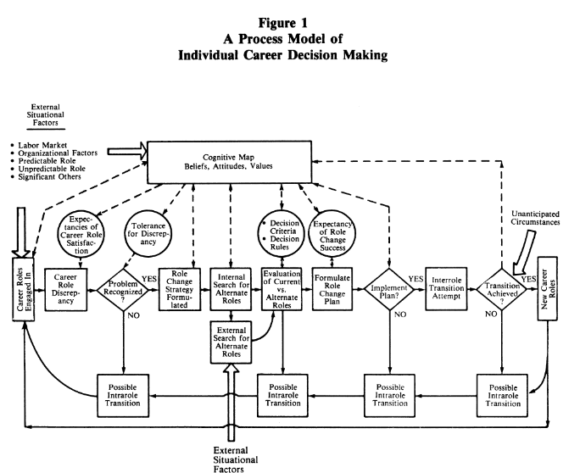

Image from (Mihal et al., 1984)

**Conclusion**:

As per my current situation, I believe it’s a relatively good choice to find more middle ground between my job and personal interests. The music industry is riskier and more unstable. It might be more suitable for me to find niche industries or specialized roles within your passion area that offer competitive salaries, or explore hybrid career paths that allow you to leverage your skills and interests in multiple ways.

Ultimately, the right choice will depend on my circumstances, values, and goals. It’s important to weigh both the financial and personal aspects of each option and choose the path that aligns best with my overall priorities and aspirations.

**Action plan:**

Current job: stay focused during my 8-hour routine, and once a week to study something relevant.

Personal interest: practice 2 times a week, to prepare myself to reach the next level of songwriting.

After all, I felt it’s very beneficial to stay reflective of my current feelings, situation, and thoughts. It helps me steer life and reduce internal conflicts.

**Reference**

Mihal, W. L., Sorce, P. A., & Comte, T. E. (1984). A Process Model of Individual Career Decision Making. *The Academy of Management Review*, *9*(1), 95–103. https://doi.org/10.2307/258236

*Models of reflection - Reflective Practice Toolkit - LibGuides at University of Cambridge Subject Libraries*. (n.d.). Retrieved March 3, 2024, from https://libguides.cam.ac.uk/reflectivepracticetoolkit/models

Wooler, S. (1982). A Decision Aid for Structuring and Evaluating Career Choice Options. *The Journal of the Operational Research Society*, *33*(4), 343–351. https://doi.org/10.2307/2581644